Date | 03 October 2026
Team ID | SWTID-2026-7735
Project Name | Auto Ticket Classification using Flow Designer
Maximum Marks | 4 Marks

Project Planning Phase
Project Planning Template (Product Backlog, Sprint Planning, Stories, Story points)
Product Backlog, Sprint Schedule, and Estimation (4 Marks)
Sprint | Epic | Story ID | Task / User Story Description | Story Points | Assigned To | Status
Sprint 1 | Governance | USN-01 | Create & initialize 'Project Update Set' in Local Update Sets | 2 | ServiceNow Admin | Completed
Sprint 1 | Schema | USN-02 | Create custom table 'Incident WorkFlow' with Auto Number (INCWF) | 3 | ServiceNow Admin | Completed
Sprint 1 | Schema | USN-03 | Configure fields: Caller, Short Description, Description, State | 3 | ServiceNow Admin | Completed
Sprint 1 | Taxonomy | USN-04 | Create Category choice list [Network, Hardware, Access, Performance] | 2 | ServiceNow Admin | Completed
Sprint 1 | Taxonomy | USN-05 | Create Subcategory choice list and configure Dictionary Dependency | 3 | ServiceNow Admin | Completed
Sprint 1 | Automation | USN-06 | Build Flow Designer Trigger (Record Created, Category is Empty) | 2 | Flow Developer | Completed
Sprint 1 | Automation | USN-07 | Implement If/Else-If keyword conditions (Wi-Fi, Projector, Password, Slow) | 5 | Flow Developer | Completed
Sprint 2 | Notification | USN-08 | Configure Send Email action with dynamic data pills to Caller | 3 | Flow Developer | Completed
Sprint 2 | Automation | USN-09 | Activate Flow Designer flow and verify system execution context | 2 | Flow Developer | Completed
Sprint 2 | QA / Testing | USN-10 | Execute functional test scenarios (WiFi, Projector, Password, Slow) | 5 | QA Lead | Completed
Sprint 2 | QA / Testing | USN-11 | Verify email dispatch in System Logs > Emails (Preview Mail) | 3 | QA Lead | Completed
Sprint 2 | Deployment | USN-12 | Mark Update Set Complete, export to XML, compile final deliverables | 5 | ServiceNow Admin | Completed
Project Tracker, Velocity & Burndown Chart: (4 Marks)
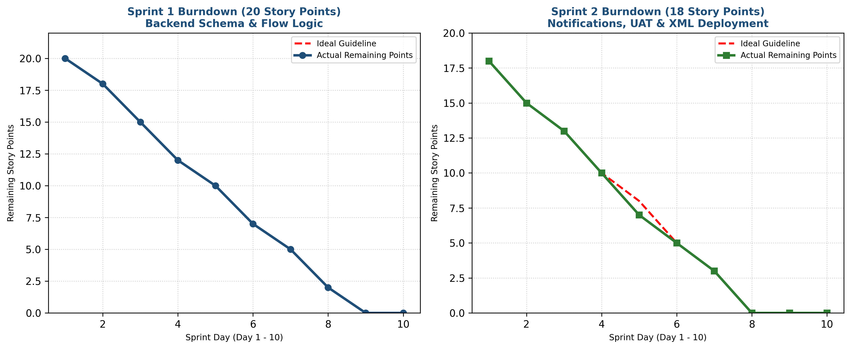
Figure 4.1: Agile Sprint Burndown Tracking for Sprint 1 & Sprint 2
Sprint 1 Burndown Tracking (20 Story Points):
Sprint Day | Planned Remaining | Actual Remaining | Completed Tasks | Status
Day 1 | 20 | 20 | Sprint Planning & Backlog Refinement | On Track
Day 2 | 18 | 18 | USN-01: Update Set created | On Track
Day 3 | 15 | 15 | USN-02: Custom Table & Auto Number created | On Track
Day 4 | 12 | 12 | USN-03: Fields & Data types provisioned | On Track
Day 5 | 10 | 10 | USN-04: Category choice lists loaded | On Track
Day 6 | 7 | 7 | USN-05: Subcategory dependent dictionary mapped | On Track
Day 7 | 5 | 5 | USN-06: Flow trigger configured & tested | On Track
Day 8 | 2 | 2 | USN-07 (Part 1): Wi-Fi and Projector logic built | On Track
Day 9 | 0 | 0 | USN-07 (Part 2): Password & Performance logic built | Ahead
Day 10 | 0 | 0 | Sprint 1 Review, Demo, and Retrospective | Completed
Sprint 2 Burndown Tracking (18 Story Points):
Sprint Day | Planned Remaining | Actual Remaining | Completed Tasks | Status
Day 1 | 18 | 18 | Sprint 2 Planning & Target Alignment | On Track
Day 2 | 15 | 15 | USN-08: Send Email action configured | On Track
Day 3 | 13 | 13 | USN-09: Flow activated in Flow Designer | On Track
Day 4 | 10 | 10 | USN-10: Scenario 1 (WiFi) & Scenario 2 (Projector) validated | On Track
Day 5 | 8 | 7 | USN-10: Scenario 3 (Password) & Scenario 4 (Slow PC) validated | Ahead
Day 6 | 5 | 5 | USN-11: System Logs > Emails inspection verified | On Track
Day 7 | 3 | 3 | USN-12: Update Set state set to Complete | On Track
Day 8 | 0 | 0 | USN-12: Export to XML & artifact validation | Completed
Day 9 | 0 | 0 | Final documentation review and sign-off | Completed
Day 10 | 0 | 0 | Final Project Submission & Presentation | Completed

